**Property Indication**

1. **Property Information:**

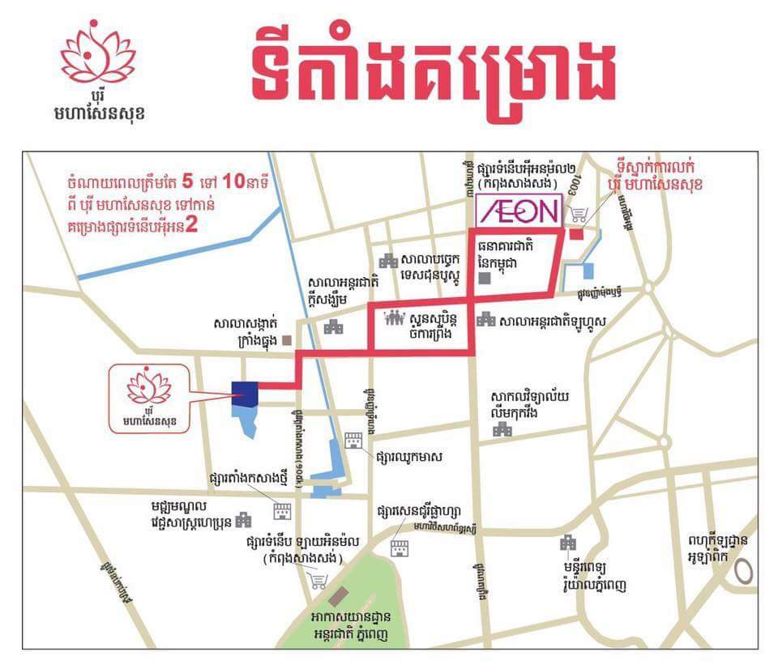

|  |  |
| --- | --- |
| **Property Address:** | No. B-150E0, St. Maha B, Phum Vimean Trung, S/k. Krang Thnug, Khan Sen Sok, Phnom Penh. |
| **Property Type** | A parcel of land accommodating an under-constructed a single-storey flat (Complete Foundation) |
| **Front Road** | 8.0 m |
| **Land Size** | 85 sqm [as per sub-divided title] |
| **Building Size:** | 57.4 sqm (4.1m*14m) |
| **Title Deed No:** | Will have hard title |
| **SPA** | USD50,925.00 |

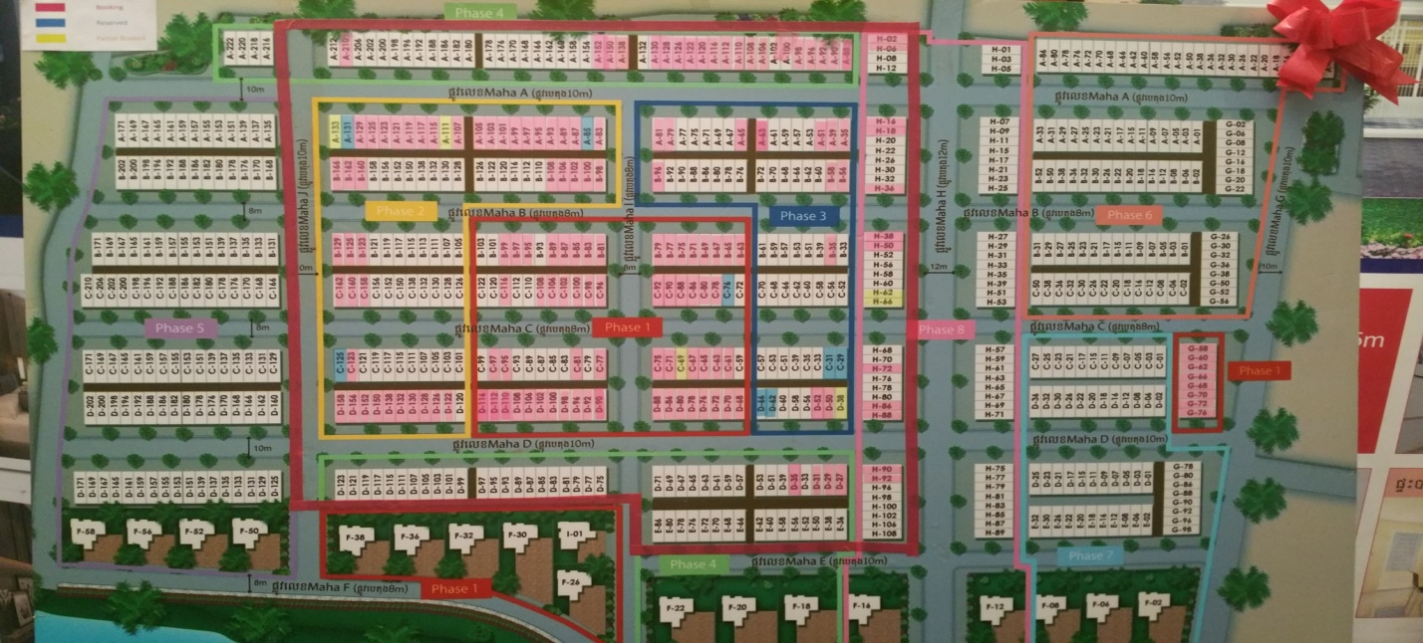

Subject property to be charged **B-150**



